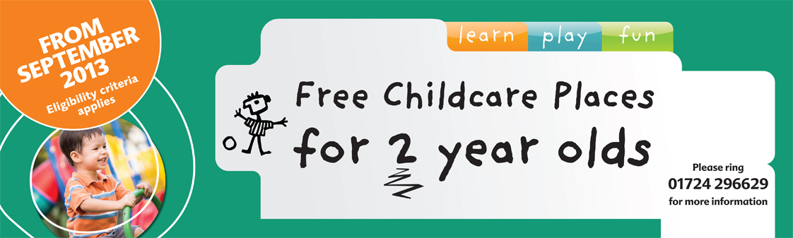

TWO YEAR OLD FUNDING
FREE PLACE INFORMATION SHEET

Free Place Information

What will my child get?

Your child will be entitled to have up to 15 hours free childcare each week during school term time. Some childminders and childcare settings* may be able to stretch the hours over school holidays so your child will attend for fewer hours over more weeks.

* private nursery, pre-school or playgroup or a children’s centre where day care is available.

I don’t want my child to attend for 15 hours, can they attend less hours?

The funding is for a maximum of 15 hours a week. If you feel your child is not ready to attend a child carer for that number of hours you are able to take less hours, with the minimum being 2 ½ hours a week. This can be increased each term as you and your child become more confident if you wish to.

When can my child start their free place?

The letter confirming your free place will say when your child can start. You can arrange an exact start date with your chosen childcare provider.

What if my circumstances change?

Your child will continue to receive a free place until they start school even if your circumstances change.

I have decided not to take up my place?

If you no longer want to access the free childcare can you please call and let us know – call 01724 296489. You may reapply at any time if your circumstances change or you want your child to start to attend a child carer to help with their early learning and play. All children are eligible for up to 15 hours free early learning and care the term after their third birthday to help them prepare for school.

Finding a Provider

Where can my child go?
You must use a childminder or childcare setting* in North Lincolnshire that is rated good or outstanding by Ofsted. The list of providers with your approval letter are all judged good or outstanding by Ofsted.

My child already attends a nursery/pre-school that is not on the list you have sent?

Please call us to discuss which nursery your child currently attends – call 01724 296489.

I want some help finding a place?

You can call the Family Information Service for advise on choosing a childcarer. They can also arrange for a Family Worker from your Local Children’s Centre to help you find a suitable place for your child.

Choosing the right provider to meet your child’s needs.

You may have used childcare before. If not the information below may help you.

Your child’s free place can be used with either a childminder, pre-school or a day nursery that is rated good or outstanding by Ofsted. All providers have a duty to work in line with the Early Years Foundation Stage Framework. This framework encourages learning through play and supports providers to develop children’s social, emotional, communication and physical skills as well as supporting them in other areas of learning.

Each type of setting offers different environments. Think about your child's personality and interests and which setting will best meet their needs.

Childminder

A childminder is someone who looks after children in their own home. They must be registered with Ofsted. They are often open all day and all year round (except when they take their holiday). They offer similar play opportunities to a group based setting but will have fewer numbers of children within a homely environment. Childminders often visit local parks and shops and may take your child to a stay and play session at the local children’s centre. Childminders can care for children of all ages.

Pre-school/Playgroup

A pre-school/playgroup can look after children from 2 years of age until they start school. For 2 year old children there will be one member of staff to every 4 children. This changes when they are 3 years of age, to 8 children. They are normally within community based buildings and are open during school hours and term time only. Sessions usually run with up to 24 children. The play environment will be set up to allow for different learning experiences e.g. home corner, painting, outdoor play.

Day Nursery

A day nursery can look after children from birth till they start school. Children are often in age appropriate rooms. For 2 year old children there will be one member of staff to every 4 children. This changes when they are 3 years of age, to 8 children. They are open all year round (except bank holidays) usually from 8am – 6pm. The play environment will be set up to allow for different learning experiences e.g. home corner, painting, outdoor play.

Contacting your chosen provider

You may want to make appointments to visit two or three providers to compare what they can offer you and your child. Take your child with you so you can see how the staff or childminder interacts with him/her.
Don’t wait till the term they can start. You can contact them once you have received your approval letter. Some settings are very popular so the sooner you have your place confirmed the better.

What should I look for?

When you visit, you may want to think about the following:
- Are you and your child made welcome by the staff or childminder?
- Are the children comfortable and happy with the Staff or childminder and with the activities and their surroundings?
- Is there a clean, pleasant, child centred building or play area and somewhere safe to play outside?

Questions you may like to ask your chosen provider?

- How will my child be kept safe and what would happen in an emergency?
- Can I look around the building to see the rooms and outside play space?
- Where will my child rest?
- What kind of food and drink will you give my child and will they be able to choose for themselves?
- What will my child do all day?
- Do parents have plenty of opportunities to say what they want for their child?
- How do you encourage good behaviour?
- Will my child be with a regular group of children? How old are they?
- Will my child be able to have the same routine they have at home?
- How will you make sure I know how my child is getting on?
- What qualifications do you have for working with children

My child has never been left with someone else before. Will they be alright?

It can be difficult to leave your child if they haven’t been left before. Once you have decided on the provider you want to use, your child will be able to do some settling in sessions to get them used to the provider and the environment they will be in. To start with you may be able to stay with them for a short period of time and then gradually build up to attending the full free hours on their own.

Your child will have a keyworker who you will be able to discuss any concerns with.
If at any time your child is unsettled, the provider will ring you and discuss how you can work together to help them settle.

Do I need to take anything to the Provider?

You will need to take your approval letter to your chosen provider so that they know your child has a free place.

You may need to take nappies, wipes and a change of clothes (due to playing in water) for your child
whilst they are at the setting.

Is it really free?

North Lincolnshire Council will pay for your child's free hours at your chosen provider. You are not required to pay any fees for your child’s free place. This includes a deposit (for the period of the free place), a compulsory uniform or lunchtime care. However, if you choose to access additional services as part of the free place, for example voluntary uniform or a meal prepared by the provider for your child, you may be charged.

I can’t find a place, what should I do?

If you haven’t been able to find a place at one of the providers on the list, please contact the Family Information Service on 01724 296629. They can then advise on what to do or where other places may be available.

Starting the Free Place

Term dates and holidays

Your chosen provider will tell you when your child should attend for their free place and when the school holidays are.

Parental Agreement

You will be asked by your provider to complete a parent agreement form. This is so they can claim the funding for your child’s free place. You will need to confirm each term that you still require the funding by either completing another parent agreement form or by signing a sheet of paper sent from the local authority. Your setting will ask you to do this.

Child’s attendance

Your child must attend for their free hours each week. If they are unable to attend, you must contact the childcare provider and tell them why. If your child is persistently absent without good reason (sickness) the childcare provider may end your child’s place. They will also inform the local authority of this as they are the ones who are paying for the place.

What should I do if I am not happy with the childcare provider?

If you have any concerns about the quality of the care that your child is receiving you can contact the Family Information Service on 01724 296629 who can either offer some advice or if it is something that Ofsted needs to investigate we will pass the information on.

Eligibility

A parent is eligible if they are in receipt of the following benefits only - Working Tax Credit is not an eligible benefit
- Income Support
- Income based Jobseekers Allowance
- Income related Employment and Support Allowance
- Support under part VI of the Immigration and Asylum Act 1999
- The Guaranteed Element of State Pension Credit
- Child Tax Credit (providing they don't receive WTC)
- 4 week ‘run-on’ of Working Tax Credit due to employment ending
You may have seen a recent announcement from the government of what the eligibility criteria will be from September 2014 when the places in North Lincolnshire increase to 1,000 (40% of 2 yr olds in North Lincolnshire). This has been confirmed as:
- They meet the eligibility criteria also used for free school meals;
- Their families receive Working Tax credits and have annual gross earnings of no more than £16,190 per year;
- They have a current statement of SEN or an Education, Health and Care plan;
- They attract Disability Living Allowance;
- They are looked after by the LA;
- They have left care through special guardianship or an adoption or residence order.

